Have your say on the future of this special place
We, the Kent Downs National Landscape Team are updating the Management Plan for the Kent Downs National Landscape - a designated Area of Outstanding Natural Beauty (ANOB).
This important plan sets out how we will care for, manage, and enhance the Kent Downs National Landscape for the years ahead. But we can’t – and don’t want to - do this without you. Whether you live in the Kent Downs, visit for walks or views, pass through on your way to work, or simply care about its future – your voice matters.
The Kent Downs is a truly special and varied place: a landscape of drama and intimacy. From ancient woodlands and delicate chalk grasslands to peaceful valleys, tiny lanes, oast houses, orchards, and the iconic white cliffs – this is a living landscape rich in nature, history, and beauty. Some species found here exist nowhere else in Britain.
Although just 93,000 people live within the Kent Downs, more than a million people live within a kilometre of its boundary. It’s a treasured escape, right on the doorstep of some of the busiest towns and cities in the South East. So, we’re asking you to help shape the future of this remarkable place.

Let’s shape the Kent Downs together
We want to know:
- The features you think make the Kent Downs most special and what you value the most?
- What matters most to you when it comes to caring for the Kent Downs?
- How can we make the Kent Downs even more enjoyable for everyone?
- If you engage or follow the Kent Downs online and how you feel about the content.
The survey should take about 5 to 10 minutes to complete. Your thoughts really will make a difference and will help us to shape the new Kent Downs Management Plan ahead of a public consultation in Spring 2026.
This survey closes at midnight on Sunday 2 November 2025.
This survey should be completed online at www.kent.gov.uk/kentdowns.
If you are unable to complete the questionnaire online, please complete this Word/paper form and return to by email to: mail@kentdowns.org.uk or post to: Kent Downs National Landscape Unit, The Granary, Canterbury Road, East Brabourne, Ashford, Kent, TN25 5LL.
Privacy: Kent County Council (KCC) is hosting this survey on behalf of the Kent Downs National Landscape Team. KCC is the employing authority for the Team. When we refer to KCC in this Policy it includes the Kent Downs National Landscape Team. KCC collects and processes personal information in order to provide a range of public services. KCC respects the privacy of individuals and endeavours to ensure personal information is collected fairly, lawfully, and in compliance with the United Kingdom General Data Protection Regulation and Data Protection Act 2018. Read the full Privacy Policy at the end of this document.
Alternative formats: If you require this survey in an alternative format or language, please email: alternativeformats@kent.gov.uk or call: 03000 42 15 53 (text relay service number: 18001 03000 42 15 53). This number goes to an answering machine, which is monitored during office hours.

Section 1: About you
Before we ask you for your views on the Kent Downs National Landscape, we would like to ask you a few quick questions about you. This information will help us to understand your views in more depth.

Q1. Are you responding as …? Please select the option from the list below that most closely represents how you are responding to this survey.
Please select one option.
A Kent Downs resident
A visitor to the Kent Downs
On behalf of a business in the Kent Downs
On behalf of an organisation
Someone who works in the Kent Downs
Something else, please tell us:

Q1a. If you are responding on behalf of an organisation or business, please tell us the name of your organisation. Please write in below.

Q2. Please tell us the first five characters of your postcode:
Please do not reveal your whole postcode. If you are responding on behalf of an organisation, please use your organisation’s postcode. We use this to help us to analyse our data. It will not be used to identify who you are.
Q3. How did you find out about this survey?
Please select all that apply.
A business card
A poster
Email from the Kent Downs National Landscape Team (@kentdowns.org.uk)
E-newsletter from the Kent Downs National Landscape Team
Email from Let’s Talk Kent / KCC’s Engagement and Consultation Team
From a Parish / Town / Borough / District Council
From a friend or family member
On social media (e.g. Facebook / Instagram / LinkedIn / Nextdoor / X)
On the Kent Downs National Landscape website
From another organisation
Something else, please tell us:

Q3a. If you have selected ‘Social media’ for Q3, please select from the list below which social media channel(s) you found out about this survey from.
Please select all that apply.
Kent Downs National Landscape (KDNL) Facebook
KDNL Instagram
KDNL LinkedIn
Kent County Council social media channels (Facebook, Instagram, LinkedIn, Nextdoor and X)
Another social media channel, please tell us:

Section 2: The Kent Downs National Landscape: An Area of Outstanding Natural Beauty

The Kent Downs National Landscape is a designated Area of Outstanding Natural Beauty (AONB) - a protected landscape recognised for its scenic beauty, wildlife, and cultural heritage. The Kent Downs National Landscape is the body responsible for helping care for and manage the AONB, ensuring it is conserved, enhanced, and enjoyed for generations to come.
Spanning from Dover in the east to Sevenoaks in the west, the Kent Downs National Landscape AONB covers around 878 square kilometres of countryside. It includes a mix of habitats and geological features, from dramatic chalk cliffs and rolling downland, to ancient woodlands, dry valleys, and historic orchards. These special features, along with the network of villages, lanes, and historic sites, make the Kent Downs a truly unique part of Kent.
The map below shows the location and extent of the Kent Downs National Landscape AONB.

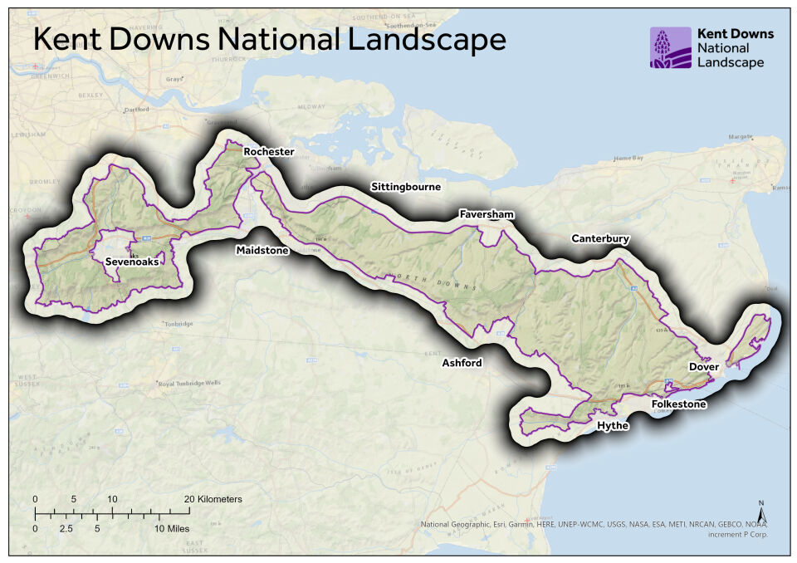
The photographs below illustrate some of the natural habitats and landscape features that characterise the Kent Downs and make it special.

Ancient lanes and paths  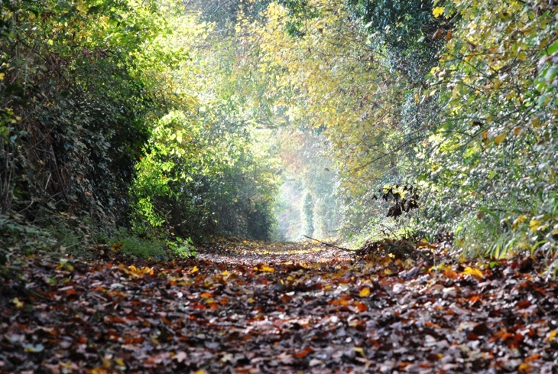 | Chalk downland (wildflower grassland)  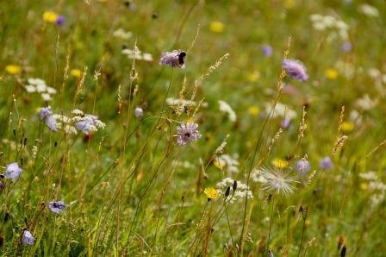
Dry valleys  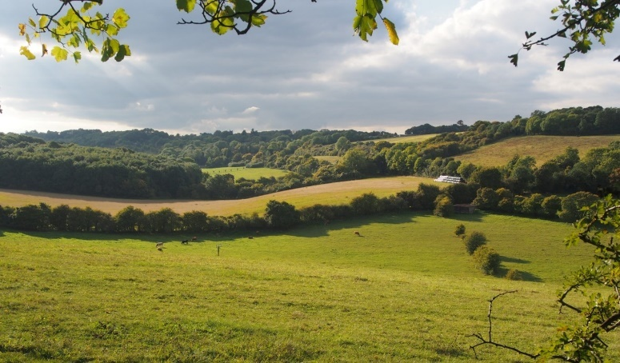 | Hedgerows  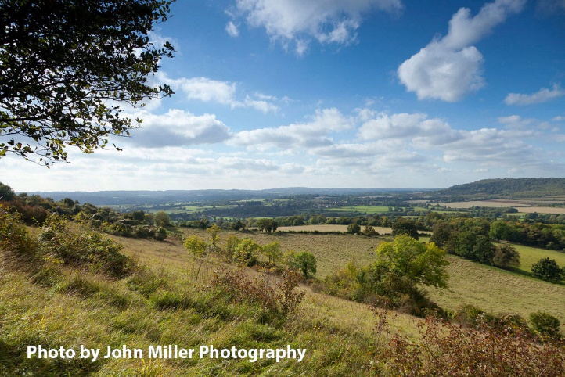
Historic parkland  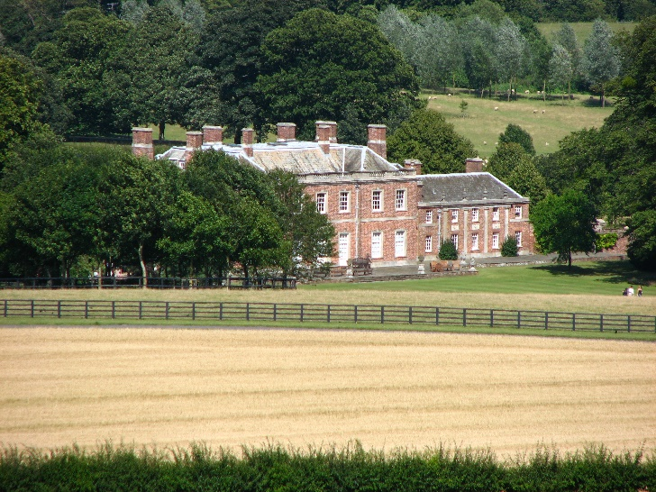 | Historic settlements and buildings  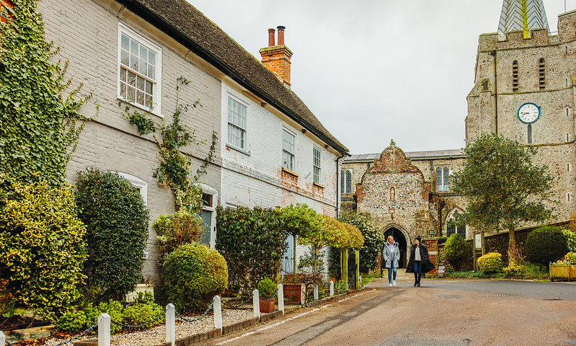

Landform and geology, cliffs and coast  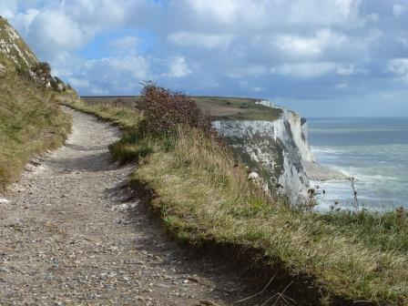 | Mixed farmland  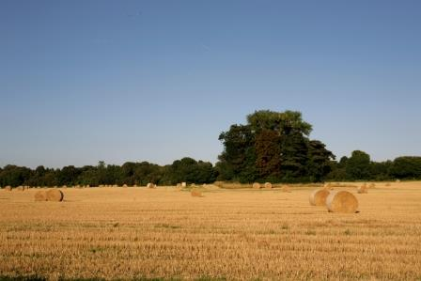
Orchards and cobnut plats  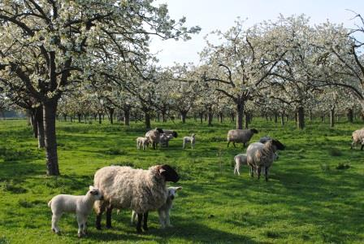 | River valleys  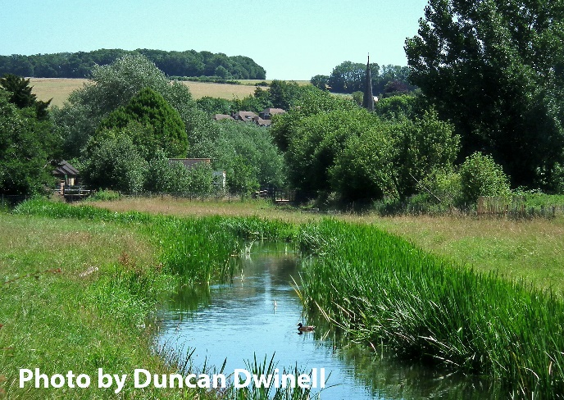
Woodland
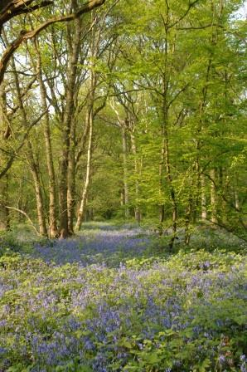

Q4. Which three features do you think make the Kent Downs most special?
Please select up to three options. A response to this question is required, please answer before moving on.
Ancient lanes and paths
Chalk downland (wildflowers, grassland)
Dry valleys
Hedgerows
Historic parkland
Historic settlements and buildings
Landforms and geology (including cliffs and coast)
Mixed farmland
Orchards and cobnut plats
River valleys
Woodland
Something else, please tell us:

Q5. What do you value most about the Kent Downs?
Please select up to three elements that make this area the most special to you. A response to this question is required, please answer before moving on.
Amenities (e.g. pub, post office)
Available local produce
Dark skies
Historic buildings and features
Local distinct highways
Opportunities for outdoor recreation
Peace and quiet
Public rights of way network (footpaths)
Scenery and views
Villages and village life
Visitor attractions (e.g. gardens)
Wildlife
Something else, please tell us:

Section 3: Your priorities for action within the Kent Downs National Landscape

Help us focus on what matters most. The Kent Downs faces many challenges but also exciting opportunities for its future.
Now we’d love to hear from you about what you think should be the top priorities for action to protect and improve this special place. Your input will directly shape the Management Plan and help us make the best plans for the Kent Downs and everyone who cares about it.

Q6. We’d like to know what matters most to you when it comes to caring for the Kent Downs. From the list below, please select your top three priorities for action in the Kent Downs.
Please select up to three options. A response to this question is required, please answer before moving on.
Conserving wildlife and habitats
Maintaining tranquillity (managing traffic, development, visitor pressure)
Managing equine land use responsibly
Offering more organised events and festivals
Preventing illegal or damaging activities (fly-tipping, abandoned vehicles, etc.)
Preventing inappropriate changes or loss of historic buildings
Protecting and enhancing views and scenic beauty
Providing better information about accessing the AONB countryside
Researching and responding to climate change impacts
Sharing more about the landscape’s special features (e.g. old field boundaries, coppice woodland)
Something else, please tell us:

Section 4: Your priorities to improve enjoyment of the Kent Downs National Landscape

Making the Kent Downs even better for everyone. We want to make sure the Kent Downs is a place where you can enjoy nature, culture, and recreation to the fullest.
Please tell us what improvements or opportunities would make your visits or daily life here even better. Your ideas will help us create a future where the Kent Downs are loved and accessible for all.

Q7. We’d love to hear your thoughts on how we can make the Kent Downs even more enjoyable for everyone. From the list below, please select the three actions you think would make the biggest difference.
Please select three options. A response to this question is required, please answer before moving on.
Control light pollution to protect the dark night skies
Encourage farmers to adopt environmentally sensitive farming techniques
Highlight local produce — what’s grown here and where to find it
Improve or increase visitor facilities (car parking, public toilets) at key sites
Improve sustainable transport options (bus links, cycle routes, walkers’ shelters, etc.)
Make it easier to get out and about by removing stiles and better marking access routes
Manage highways in a way that respects the sensitivity of the landscape
Place greater emphasis on development control
Protect peace and quiet by managing traffic and controlling illegal off-road use
Provide better information about the wildlife in the AONB
Share more about where to go in the AONB (woodlands, gardens, historic sites, community orchards)
Something else, please tell us:

Section 5: Letting you know about the Kent Downs National Landscape

This section focuses on how we communicate with you. We want to understand how you keep up with news, events, and stories from the Kent Downs and how useful you find our online channels.

Q8. Please tell us how often you follow or engage with the Kent Downs National Landscape online.
Please select one option per channel/row.
Online channel | Daily | Weekly | Monthly | Less often | Never | I don’t know
Facebook
Instagram
LinkedIn
E-newsletter / email updates
Website

If you follow or engage with any of the Kent Downs National Landscape online channels, please answer questions 9 to 10.
If you never follow or engage with the Kent Downs online, please move on to question 11.

Q9. Do you find the content we share on each channel useful and interesting?
Please select one option/channel per row.
Online channel | Yes | Partly | No | Not applicable – I don’t follow this channel | I don’t know
Facebook
Instagram
LinkedIn
E-newsletter / email updates
Website

Q9a. If you have answered ‘Partly’ or ‘No’ for any of these channels, please tell us why in the box below. If your comment is about a specific online channel(s), please make it clear in your answer.

Q9b. If you have any suggestions for how we can make any of the Kent Downs National Landscape online channels more useful and/or interesting, please tell us in the box below. If your comment is about a specific online channel(s), please make it clear in your answer.
Q10. What type of content would you like to see more of?
Please select all that apply.
Community projects and volunteering opportunities
Events and activities
Landscape and geology features
Local wildlife and nature updates
News about planning, conservation and land management
Something else, please tell us:

Q11. If you don’t follow or use any of the Kent Downs National Landscape online channels, what are the main reasons?
Please select all that apply.
I don’t read e-newsletters or emails
I don’t use social media
I’m not interested
I wasn’t aware these channels existed
Something else, please tell us:

Q12. If there anything else you would like to tell us to help us shape the Kent Downs Management Plan, please write in the box below.
Please do not include any personal information that could identify you or anyone else in your answer.

Section 6: Equality monitoring

Let’s finish with a bit about you. We are asking these optional questions to help us meet our obligations under the Public Sector Equality Duty and to help make sure we’re hearing from as many people with different protected characteristics as possible. This helps us to understand who we are reaching and how different people feel about the Kent Downs National Landscape.
Your answers are confidential and we won’t share them with anyone else. You don't have to answer any questions you’d rather skip – just leave them blank and move on.
It is not necessary to answer these questions if you are responding on behalf of an organisation.

Q13. Which of these age groups applies to you?
Please select one option.
 | 16 or under |  | 17-24 |  | 25-34 |  | 35-54 |  | 55-64
 | 65-74 |  | 75-84 |  | 85+ |  | I prefer not to say

Q14. Do you have a disability, health condition, physical or mental impairment that has a substantial and long-term negative effect on your ability to do normal daily activities? Please select one option.
Yes
No
I prefer not to say

Q14a. If you answered ‘Yes’ to Q14, please tell us if any of the following disabilities or health conditions apply to you. You may have more than one, so please select all that apply. If none of these applies to you, please select ‘A different disability or health condition’ and give brief details.
Physical
Sensory (hearing, sight or both)
Longstanding illness or health condition, such as cancer, HIV/AIDS, heart disease, diabetes or epilepsy
Mental health condition
Learning disability
Neurodivergent, such as ADHD, autism, dyslexia and dyspraxia
I prefer not to say
A different disability or health condition

If you have selected ‘A different disability or health condition’, please tell us:

A Carer is someone who gives unpaid care or help to anyone because they have a long-term physical or mental health condition or illness, or problem related to old age. Both children and adults can be Carers.
Q15. Are you a Carer? Please select one option.
Yes
No
I prefer not to say

Q16. What is your religion or belief?
Please select one option.
No religion or belief
Atheist
Christian
Buddhist
Hindu
Jewish
Muslim
Sikh
A different religion or belief, please tell us:
I prefer not to say

Q17. What is your ethnic group? Please select one option.
White
English, Scottish, Welsh, Northern Irish or British
Irish
Gypsy or Irish Traveller
Roma
Any other White background, please tell us:

Please see over the page for more ethnic groups.

Mixed or Multiple
White and Black Caribbean
White and Black African
White and Asian
Any other Mixed or Multiple background, please tell us:

Asian or Asian British
Indian
Pakistani
Bangladeshi
Chinese
Any other Asian or Asian British background, please tell us:

Black, Black British, Caribbean or African
Caribbean
African background, write in below
Any other Black, Black British, or Caribbean background, please tell us:
Another ethnic group
Arab
Roma
Any other ethnic group, please tell us:

Q18. What is your sex? A question about gender identity will follow.
Please select one option.
Female
Male
I prefer not to say

Q19. Is the gender you identify with the same as your sex registered at birth?
Please select one option.
Yes
No, please tell us your gender identity:
I prefer not to say

Q20. Which of the following best describes your sexual orientation?
Please select one option.
Heterosexual / Straight
Gay or Lesbian
Bisexual
I prefer to define my own sexuality, please tell us:
I prefer not to say

Thank you for taking the time to complete our survey and for helping to protect and conserve the Kent Downs National Landscape - your voice truly matters!
All the information you provide will be held securely by KCC and used only for matters relating to the Kent Downs National Landscape.
If you’d like to stay up to date with news, events, and ways to get involved, why not sign up to the Kent Downs e-newsletter. Subscribe at: https://tinyurl.com/KDNLnews
You can also find the Kent Downs on Facebook, Instagram, and LinkedIn by searching for ‘Kent Downs National Landscape’.

Engagement and Consultation Survey Privacy Policy
Last updated: 7 April 2025

Who are we?
We, Kent County Council (KCC), take our privacy obligations seriously and we’ve created this privacy policy to explain how we treat your personal information collected in this survey. Personal information is information we hold which is identifiable as being about you.
Our collection, use and disclosure of your personal information is regulated under the United Kingdom Data Protection Regulation and the Data Protection Act 2018. We are responsible as ‘controller’ of that personal information for the purposes of those laws. Our Data Protection Officer is Benjamin Watts.
KCC is hosting this survey on behalf of the Kent Downs National Landscape Team. KCC is the employing authority for the Team. When we refer to KCC in this Policy it includes the Kent Downs National Landscape Team.

The personal information we collect and use

Information collected by us
In the course of responding to consultations published by Kent County Council we collect the following personal information when you provide it to us:
- responses to engagement and consultation questionnaires or surveys
- equality data collected through questionnaire response - age, disability, gender reassignment, pregnancy or maternity, race, religion or belief, sex, sexual orientation and caring responsibilities
- employment and education details
- postcode.
We ask you not to provide information that will identify you in your response in this questionnaire or survey.
You do not need to submit any equality or postcode information if you do not want to. KCC is committed to the principle that all our customers have the right to equality and fairness in the way they are treated and in the services that they receive. Any information you do give will be used to see if there are any differences in views for different groups of people. Equality monitoring data collected through questionnaires or surveys may be used for monitoring so we can see which communities we are reaching and then put actions in place to reach other groups that are relevant to the engagement or consultation activity.

We will not ask you to provide your name, email or full home address. If you provide this information, it will not be entered into spreadsheets or databases used to process response data and will not be used in producing reports. We will follow our Data
Protection policies to keep your information secure and confidential. Your equality data will be anonymised before it is shared with external organisations who have been commissioned on individual projects to undertake analysis and reporting on our engagement and consultation activities.

How we use your personal information
We collect and use this information in order to:
- understand your views about a particular topic or KCC activity
- analyse consultation and engagement activity
- inform KCC’s future strategy, policy, service design and budget planning
- undertake equality monitoring.

We may use your postcode to analyse the geographical spread of responses and in some cases to understand in more detail how responses might be impacted by location. We will only ask you for the first five characters of your postcode to avoid being able to identify specific households in less populated areas.
We may use your postcode to carry out a type of profiling to estimate which one of a number of lifestyle groups you are most likely to fall into. We would do this using geodemographic segmentation tools. We do not make any decisions about individual service users based solely on automated processing, including profiling.

How long your personal data will be kept
We will hold any personal information provided by you in this questionnaire for up to six years following the closure of a consultation. Our Retention Policy is available from our website or on request.

Reasons we can collect and use your personal information
We rely on UK GDPR Article 6(1)(e): ‘processing is necessary for the performance of a task carried out in the public interest' and Article 6(1)(c) ‘for compliance with a legal obligation to which the controller is subject’ as our lawful basis.
We rely on Article 9(2)(g) ‘processing is necessary for reasons of substantial public interest’ (statutory etc. and government purposes, equality of opportunity or treatment) as the lawful basis on which we collect and use your special category data.

The processing is necessary for our statutory purposes including equality monitoring or to understand the potential impact of proposals on conditions related to personal or special category data within your response (e.g. when identifying or keeping under review the existence or absence of equality of opportunity or treatment between groups of people with the view to enabling such equality to be promoted or maintained). It is necessary for identifying or keeping under review the existence or absence of equality of opportunity or treatment between groups of people with the view to enabling such equality to be promoted or maintained. You can read KCC’s Equality Policy on our website or on request.

Who we share your personal information with
We may share your personal data with those listed below:
- services within the Council who are responsible for the management of the engagement or consultation activity
- a third-party supplier who has been contracted to independently analyse the consultation responses
- organisations such as schools and academies with whom we may be consulting in partnership or on behalf of
- district or borough councils or government departments with whom we may be consulting in partnership or on behalf of.
We will share personal information with law enforcement or other authorities if required by applicable law.
Any personal information provided that could identify you will be removed before consultation or engagement results are published.
We use an online platform to collate feedback anonymously. The software is provided by Granicus-Firmstep Limited.

Your rights
Under UK GDPR you have a number of rights which you can access free of charge which allow you to:
- know what we are doing with your information and why we are doing it
- ask to see what information we hold about you
- ask us to correct any mistakes in the information we hold about you
- object to direct marketing
- make a complaint to the Information Commissioner’s Office.
Depending on our reason for using your information you may also be entitled to:
- ask us to delete information we hold about you

- have your information transferred electronically to yourself or to another organisation
- object to decisions being made that significantly affect you
- object to how we are using your information
- stop us using your information in certain ways.
We will always seek to comply with your request, however, we may be required to hold or use your information to comply with legal duties.
For further information about your rights, including the circumstances in which they apply, see the guidance from the UK Information Commissioner’s Office (ICO) on individuals’ rights under UK GDPR.
If you would like to exercise a right, please contact the Information Resilience and Transparency Team at data.protection@kent.gov.uk.

Keeping your personal information secure
We have appropriate security measures in place to prevent personal information from being accidentally lost or used or accessed in an unauthorised way. We limit access to your personal information to those who have a genuine business need to know it. Those processing your information will do so only in an authorised manner and are subject to a duty of confidentiality.
We also have procedures in place to deal with any suspected data security breach. If we have your contact information we will notify you and any applicable regulator of a suspected data security breach where we are legally required to do so.

Who to contact
Please contact the Information Resilience and Transparency Team at data.protection@kent.gov.uk to exercise any of your rights, or if you have a complaint about why your information has been collected, how it has been used or how long we have kept it for.
You can contact our Data Protection Officer, Benjamin Watts, at dpo@kent.gov.uk. Or write to Data Protection Officer, Kent County Council, Sessions House, Maidstone, Kent, ME14 1XQ.
The United Kingdom General Data Protection Regulation also gives you the right to lodge a complaint with the Information Commissioner who may be contacted at https://ico.org.uk/concerns or telephone 03031 231113.
For further information about our privacy policy and related information practices, or to access or correct your personal information, please contact us at consultation@kent.gov.uk.

