Hythe to Folkestone Walk: Art and Nostalgia accessibility guide
Table of Contents
Hythe to Folkestone Walk: Art and Nostalgia accessibility guide 1
About this Guide 2
Google Maps 360 View 2
How to use what3words 2
Overview 3
Accessible Parking 3
Accessible Toilets 5

About this Guide
This accessibility guide is an accompaniment to the following guides which describe the route:
- Hythe to Folkestone Art and Nostalgia
- Folkestone Harbour Arm accessibility information
This guide provides an overview of accessibility features and potential barriers along the route. While we have highlighted key considerations, it is not possible to include every example of every barrier. Please take care and plan thoroughly before setting out, especially at different times of the year when conditions, surfaces, and access to facilities may change. The route is shared with cyclists and joggers, so extra care is always needed. As the route follows the coastline, weather can be changeable, so it is advisable to check the local forecast before beginning your journey. Some sections may include hazards such as low walls, steep drops, and areas near water, so caution is always required.
If you would like to convert this guide into an alternative format, RoboBraille is a free service that converts documents into accessible formats, including audio, Braille, and e-books.
My Computer My Way is an online guide by AbilityNet that helps people customise their devices for better accessibility, offering step-by-step instructions for Windows, macOS, iOS, Android, and browsers.

Google Maps 360 View
To learn more about the surroundings along this walk, you can explore the 360 degree Google Map for English Coast Path Dungeness to Dover (where the route first meets the coast path.) This resource provides a good sense of the landscape and features you’ll encounter.

How to use what3words
As recommended by the Royal National Institute of Blind People (RNIB), key locations have been given using what3words. what3words is a global addressing system that divides the world into a grid of 3m x 3m squares, assigning each square a unique combination of three words to make locations easy to find and share.
- Get the App or Website
  - Download the what3words app (iOS/Android) or go to what3words.com.
- Find Your Location
  - Use the map or search bar to find where you are or where you want to go.
  - Zoom in and tap the exact spot.
- Get the 3-Word Address
  - Each 3m x 3m square has a unique address like ///apple.orange.banana.
- Navigate
  - Tap “Navigate” to open directions in Google Maps, Waze, or other apps.
- Share
  - Copy the three words and share them via text, email, or social media.

Overview
From the whistle of a steam train to the art scene of Folkestone, amble along this beautiful stretch of the King Charles III England Coast Path (KCIIIECP) taking in the peace and tranquillity of the Royal Military Canal and the vibrancy of the Folkestone Harbour Arm and Creative Quarter.
- Location: Start at Scanlons Bridge Road, Hythe, CT21 6LD (what3words: ///verifying.lasts.flick).
- Distance: 6 miles (9.6km)
- Explorer Map: 138
- Parking: Pay and display parking in Hythe.
- Refreshments and Facilities: Vintage style tearoom in Hythe, choice of eateries in Sandgate, food and drink at Folkestone Harbour and Harbour Arm.
- Public Transport: Wave 102 and 16 Gold bus services run from Folkestone to Hythe. Check Kent Connected to plan your journey.

Accessible Parking
Below are car parks that are most closely related to the route. A full list of car parks accessibility information, opening times and charges can be accessed via Folkestone and Hythe District Council’s Car Parks in the district web page, this page also hosts a List of car parks in the district.

Romney Hythe and Dymchurch Railway Station Car Park
3 accessible bays in station car park:

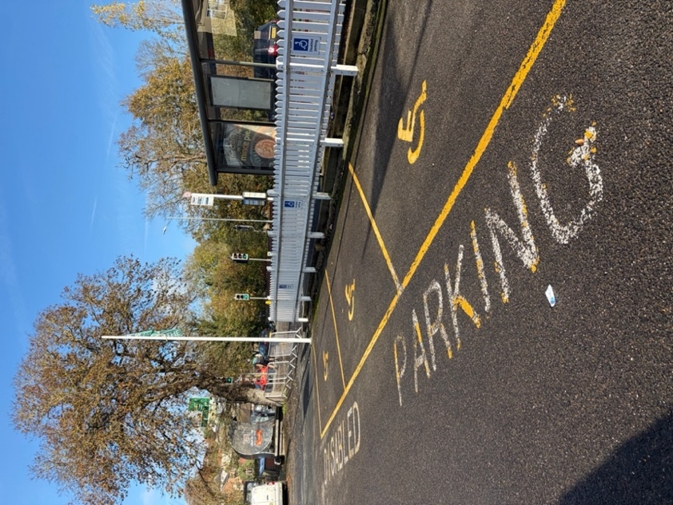

2 further bays adjacent to canal and opposite the Light Railway Restaurant:

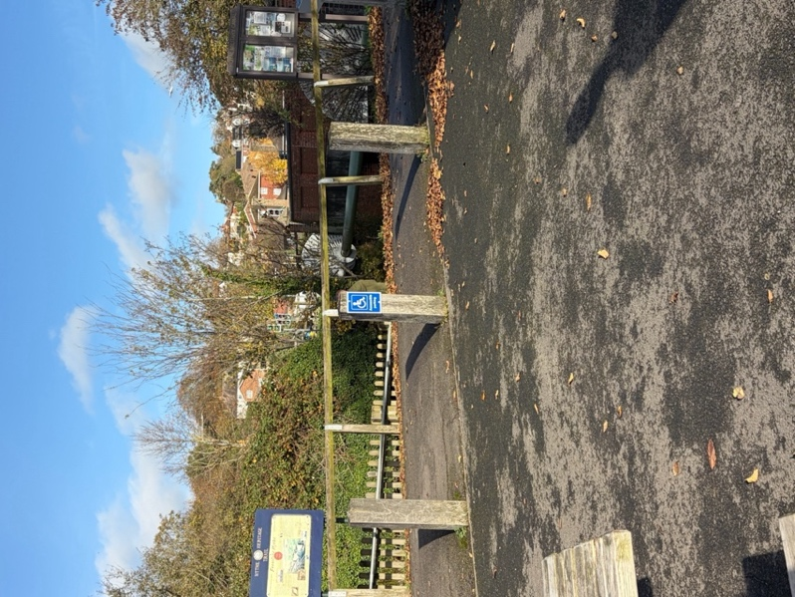

The station is accessed via the Railway Shop, and a small ramp is available for customers to access the Shop.
- what3words: ///slurping.sobs.taster

Accessible Toilets
Below are toilets that are most closely related to the route. A full list of toilets in the area including accessibility information and opening times can be accessed via Folkestone and Hythe District Council’s public toilet facilities web page.
- Romney Hythe and Dymchurch Station
  - what3words: ///slurping.sobs.taster
  - There are no accessible toilets in the car park however the station features an accessible toilet which is located at the shop end of Platform 3 and can be accessed from the car park via the shop. The station is accessed via the Railway Shop, and a small gradual ramp is available for customers to access the Shop. Baby changing facilities are also available. Hythe Café and the Vintage Tea Room can be found in the building adjacent to the Railway Shop. Entrances are at street level. Limited car park spaces are available.
- State Street
  - what3words: ///bounded.coherent.conductor
  - RADAR key required.
  - Only open during the summer season (1 April - 30 September).
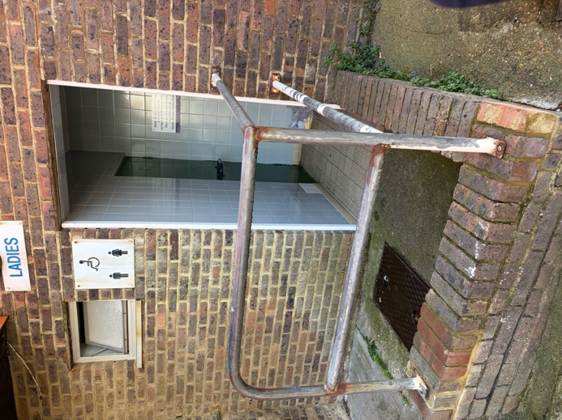 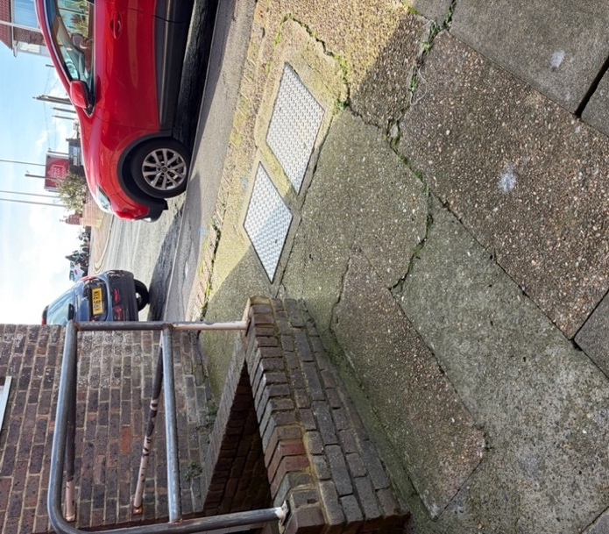

- Marine Parade, Hythe Pool
  - what3words: ///smirking.latest.torches
  - RADAR key required.
  - Left-hand transfer.
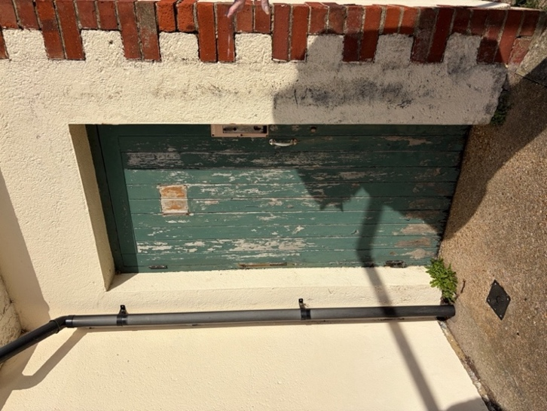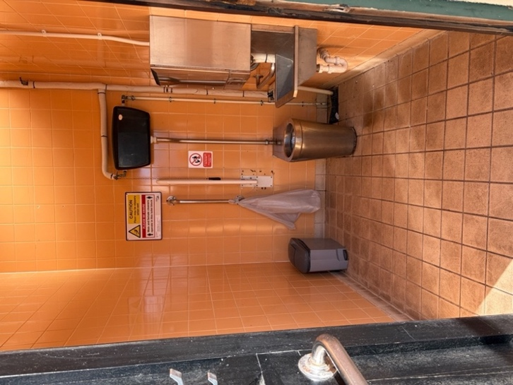

- Sandgate Public Toilets
  - what3words: ///decisions.essential.bikers
  - RADAR key required.
  - Left-hand transfer.

- 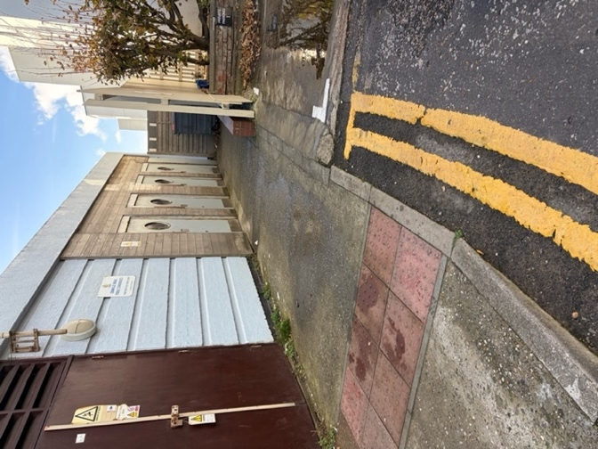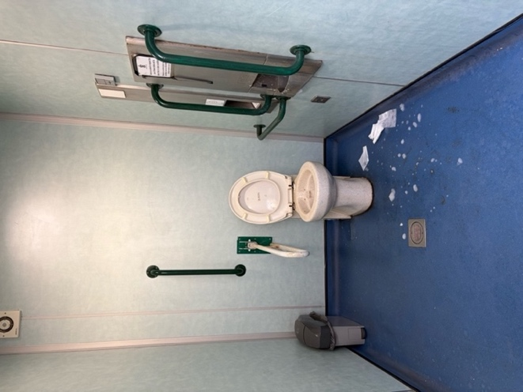

Changing Places
- Lower Leas Coastal Park Toilet Block
- what3words: ///filed.podcast.helpfully
- Changing Places website entry
  - Facility Features
    - Bench - Height Adjustable, Adult Sized, Wall Mounted
    - Hoist - Ceiling , Loop
    - Peninsular Toilet
    - Washbasin Height Adjustable
    - Slip Resistant Floor
    - Floor Space (sq. m) - 12.0
    - Emergency Alarm
    - Privacy Screen
    - Paper Roll
    - Accessible Shower
    - Colostomy Shelf
    - Signage in the room
    - Drop down grab rails
    - Wall grab rails
    - Large Bin
    - Door Width (m) - 0.00
    - Ceiling height (m) - 2.40
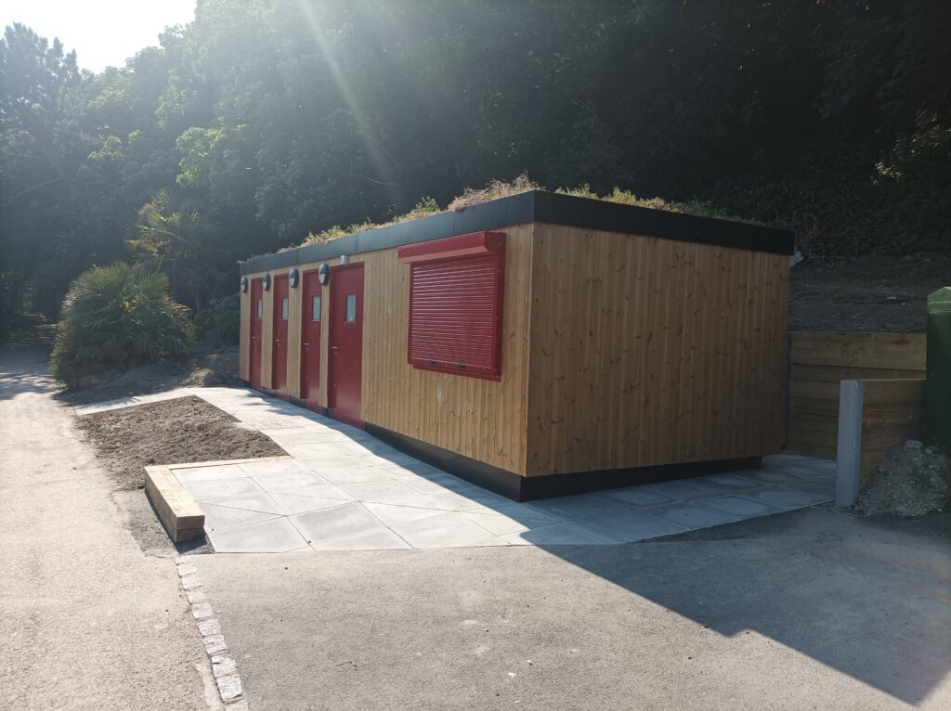

There are accessible toilets located across Folkestone Harbour:
- Platform 2 in the Harbour Station
  - what3words: ///sends.fuses.dodging
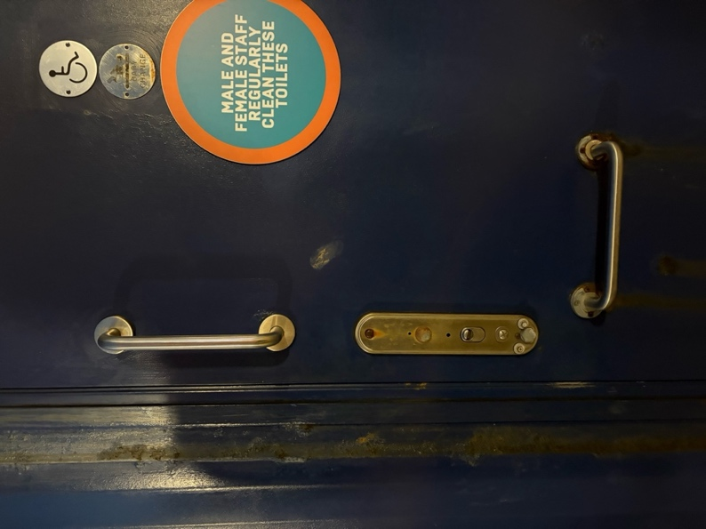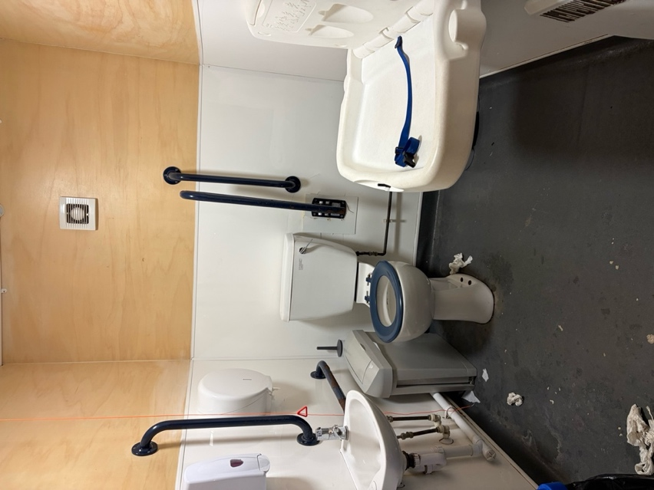

- The Goods Yard
  - what3words: ///wove.syndicate.chew
- Platform 4 on the Harbour Arm
  - what3words: ///preheated.lots.exhale
There are also accessible toilets in the following commercial outlets (toilets for customer use only):
- Sailbox
  - what3words: ///outraged.staked.investors
- The Board Room
  - what3words: ///rival.mealtime.national
- Brewing Brothers Beachside
  - what3words:///shout.fixtures.cheetahs
- Little Rock
  - what3words: ///shared.shrubbery.hedge
Folkestone Harbour Arm accessibility information

Route Description
- Your walk begins at the west end of Hythe right next to the Hythe station of the Romney, Hythe and Dymchurch Railway, found just off Scanlons Bridge Road in Hythe. The footpath runs right alongside the Royal Military Canal and provides instant tranquillity from the busy market town of Hythe.

Leaving the heart of Hythe behind, walk down the Royal Military Canal and, in summer, admire the electric excursion boat, the rowing boats and canoeists as they make their way gracefully along. Just before the Fisherman’s Beach and the two visible Martello Towers ahead, turn left into St Leonard’s Road to follow the KCIIIECP.
Accessibility
The station is accessed via the Railway Shop, and a small ramp is available for customers to access the Shop:

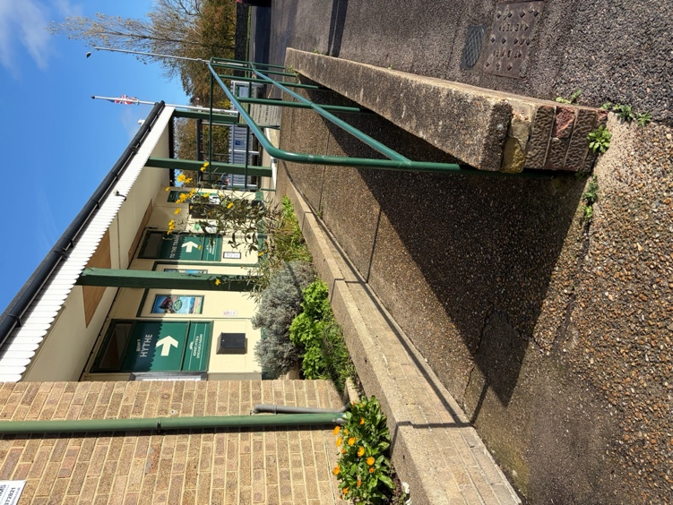

The starting point near Hythe Station offers level access with firm, even and well-maintained paths, suitable for wheelchairs and mobility aids. There is tactile paving:

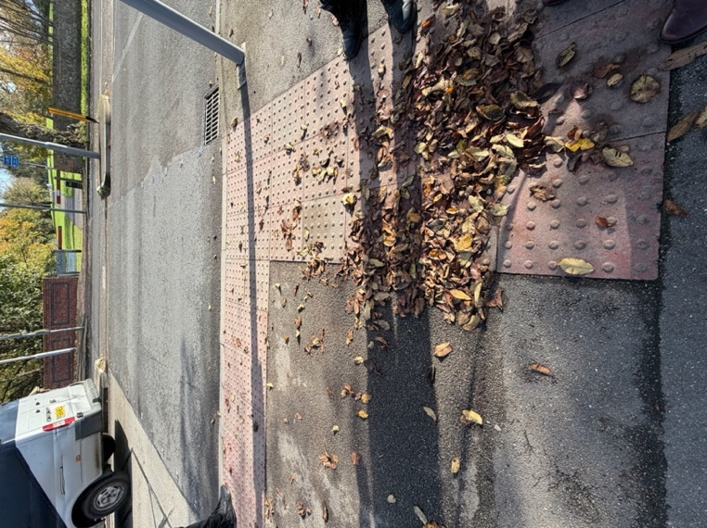

For key road crossings and accessible pedestrian signals (APS). There are benches at intervals for resting, and the route is generally quiet with minimal traffic noise. No steep gradients are present at this stage, and the surface is predominantly tarmac or compacted gravel:
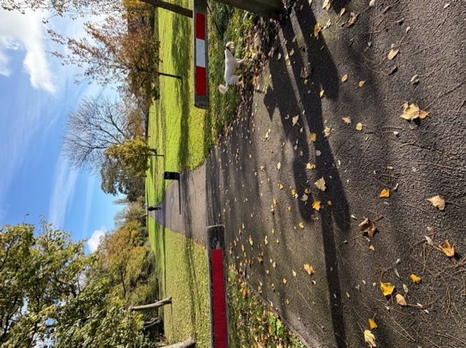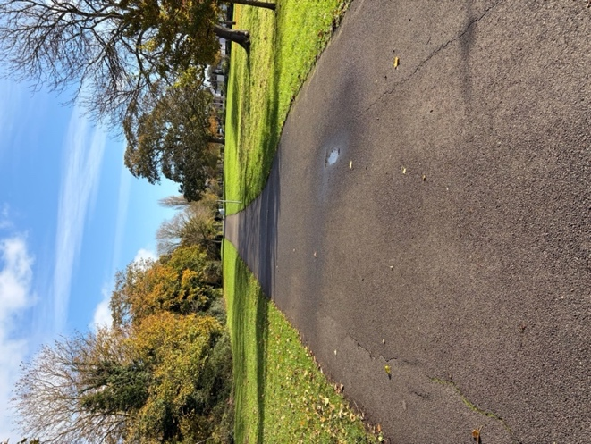
St Leonards Road has several narrow sections where tree roots have distorted the pavement, creating uneven surfaces and reducing walkway width:

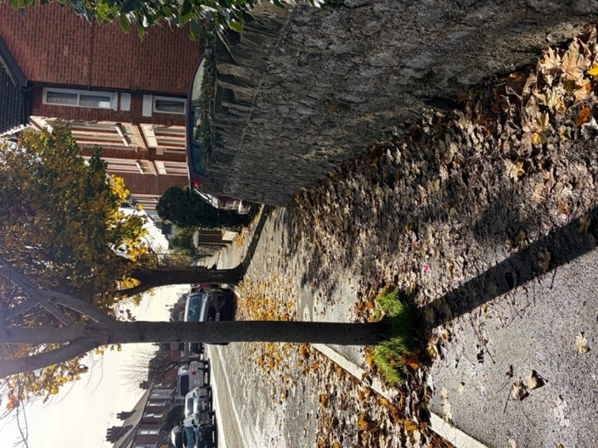
These conditions make access challenging for people with limited mobility. Fallen leaves and other debris further increase the risk by obscuring kerb edges and road boundaries, making them harder to anticipate. This issue affects both sides of the road. Additionally, street furniture such as road signs further restricts available space on some pathways:
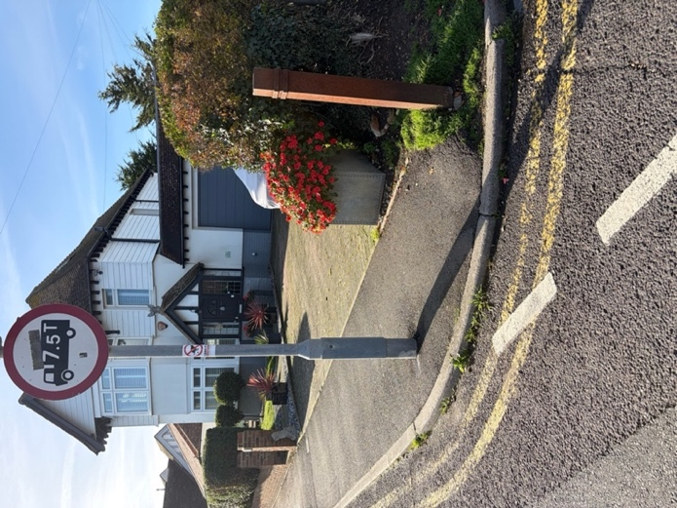

It may be best for some users to therefore start the walk at the beginning of the promenade (what3words: ///flagpole.sliding.smaller), seeking parking along West Parade (what3words: ///originals.acclaimed.pastime).
Approaching the outskirts of Hythe, you will pass Seabrook, marking one end of the Royal Military Canal which runs for 28 miles to Cliff End in East Sussex. The promenade leading from Seabrook to Hythe is very popular with walkers and joggers in the summer months. You can appreciate the open gulf of Hythe Bay by spotting Dungeness Power Station in the distance at the other end of the bay.
Accessibility
The promenade from Seabrook to Hythe is wide, flat, and predominantly surfaced with smooth tarmac with a concrete edge, making it accessible for wheelchairs, scooters, and prams. There are frequent seating areas. The route is shared with cyclists and joggers, so extra care is always needed. From the end of St Leonards Road there is a small ramp that leads to the start of the promenade:
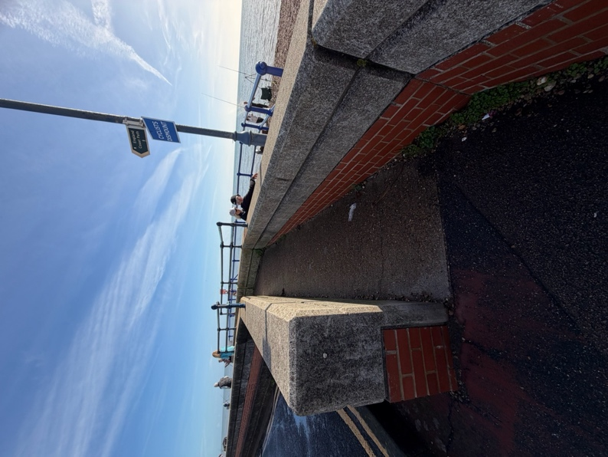

Please be aware that there is no railing to the seaward side of the promenade and a drop of a couple of metres towards the shingle beach. The concrete edge is nearest the seaward side and the drop onto the beach:
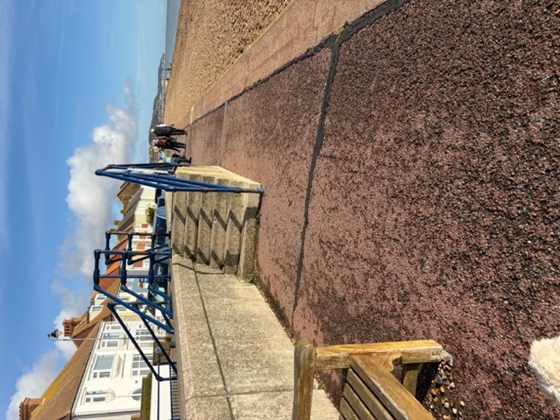
- Tarmac with a concrete edge is typical of the predominant surface on the route. There are also some slightly recessed utility covers in places. There may also be movable street furniture such as shop signs intermittently throughout the route:

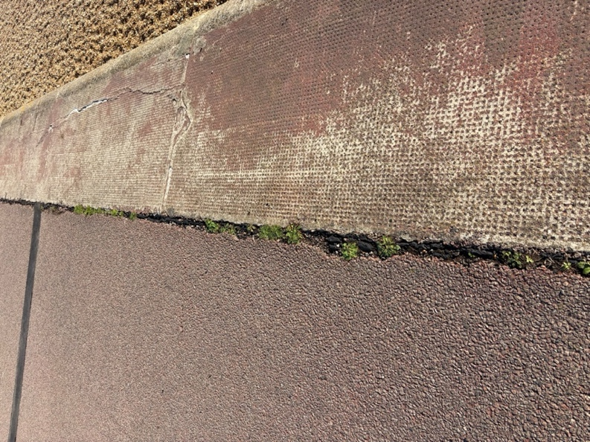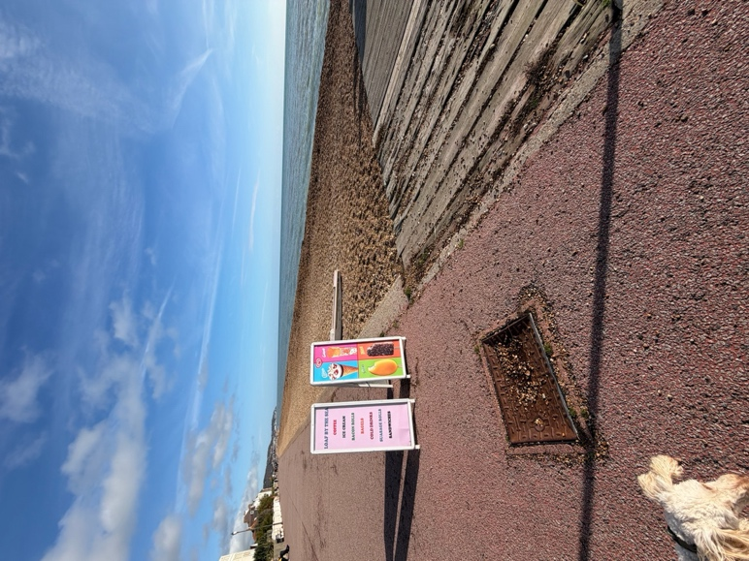
- Stade Street accessible toilet is located along this first stretch (what3words: ///bounded.coherent.conductor), with Marine Parade accessible toilet next in line along the route (what3words: ///smirking.latest.torches).

This is a long section but there are breaks in the left-hand side wall (town ward side) that gives access to the roadway and potential parking places:
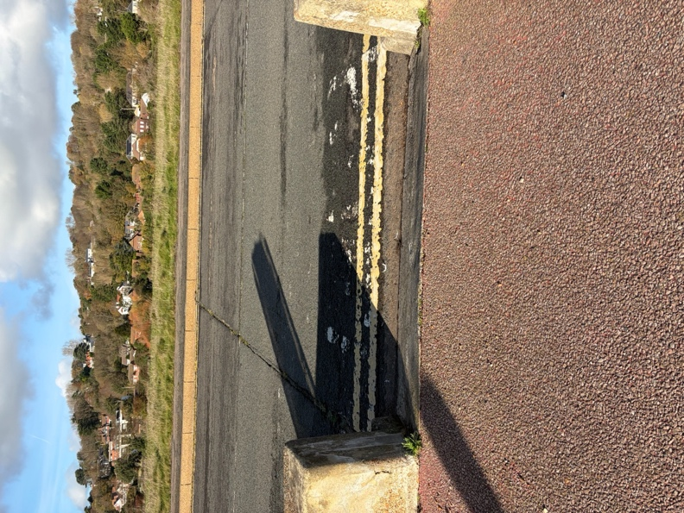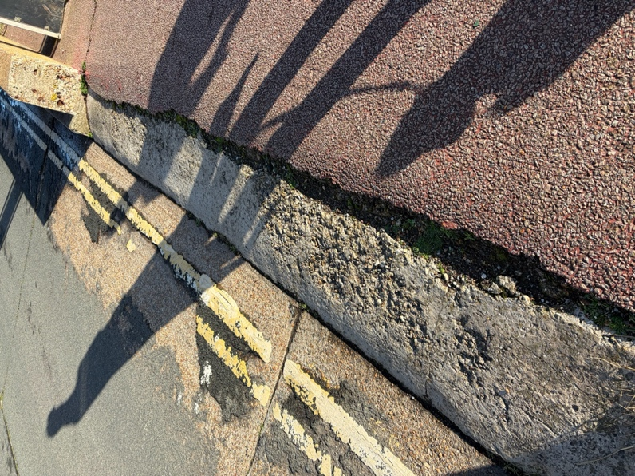

There are few places to shelter in bad weather until you reach the Tram Shelter (what3words: ///older.padlock.presenter), which requires you to cross the road via one of these breaks in the wall. It should be noted that these breaks in the wall are temporary flood gates. Barriers are installed at these locations when there is a flood risk such as during spring tide, stormy weather etc. Access to the road is uneven and extra care should be taken when exiting the route.

Battery Point Car Park (what3words: ///remain.track.houseboat) is at the end of this section and has an accessible parking bay.

Shortly beyond Battery Point Car Park (the section of the route between what3words: ///pounces.pill.takers and ///haystack.tribal.zoomed the route runs adjacent to A259 Sandgate Esplanade. Although the route remains flat, the surface changes from tarmac/concrete to tarmac with a high wall on the beachward (right-hand) side and a roadside kerb to the left-hand side:

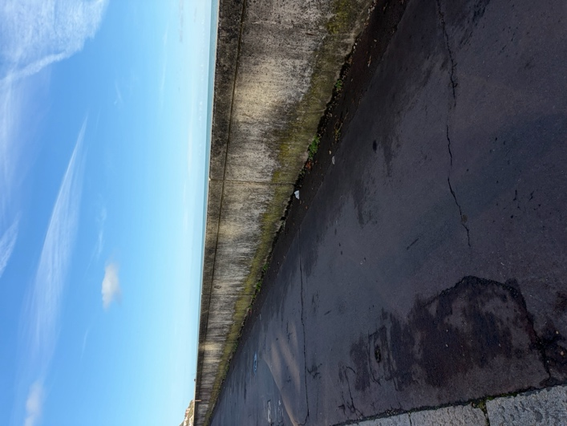

- After approximately one mile, you will reach Sandgate village which spans 2.5 km of Kent coastline fringed with the English Channel and clustered beneath steep wooded slopes. It now offers visitors an eclectic choice of opportunities to eat, drink and relax.
Accessibility
Sandgate village has level pavements along the main route, though some side streets may have narrow or uneven sections. Dropped kerbs are present at most crossings, and the main walking route remains flat with good surfacing.

- Shortly afterwards, you’ll pass along Sandgate Beach, a peaceful pebble shore set against the lure of the protected cliffs and green hills clearly in the right light. Sandgate was once a little bastion that protected against invasion with the Martello towers standing proud on the heights. These towers were small forts that were constructed as defensive measures in the 19th century and typically would have housed a single officer and 15 to 25 men – a tight fit!
Accessibility
Access to Sandgate Beach is limited for wheelchairs due to the pebble surface, but the adjacent promenade provides excellent accessibility with a smooth, level path. There are benches overlooking the beach and occasional ramps leading to viewing points:

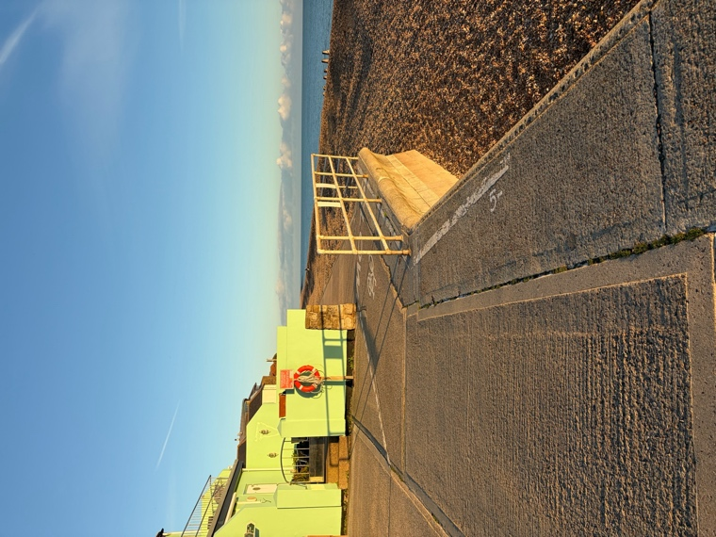

No steep inclines are encountered along this stretch. There are accessible toilets situated behind the Boat House café (what3words: ///grudges.dissolves.poker).
Accessibility
The Martello Towers themselves are historic structures with no internal accessibility, but they can be viewed from the level path. The surrounding route remains flat and well-surfaced.

- Pass Sandgate Castle 5 , the first of King Henry VIII’s ‘device forts’, which guards a beach situated just 25 miles from the continent, making it a likely target in the event of an invasion. After about 10 minutes, you will pass a row of brightly coloured beach huts.

Accessibility
Sandgate Castle is visible from the promenade, which continues to offer a smooth, level surface The brightly coloured beach huts are positioned along the route and can be enjoyed without leaving the accessible path. Seating is available nearby, and gradients remain gentle. There are some structures on the left-hand side that cause some narrowing to the path in places:

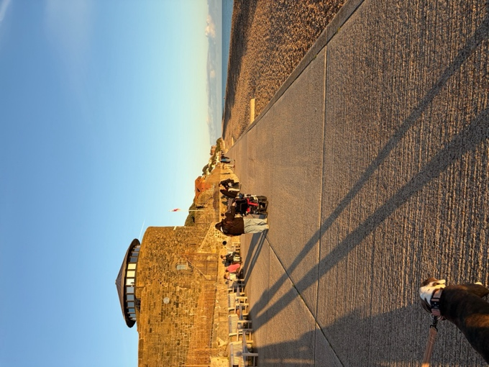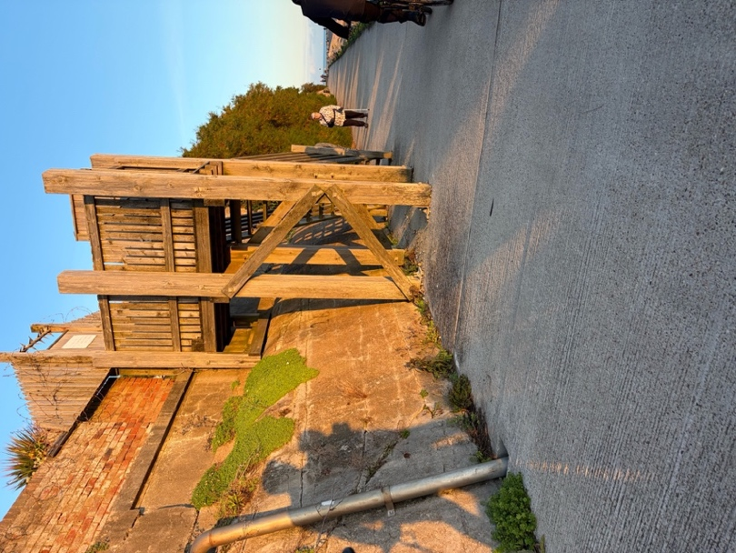

At what3words: ///handfuls.internet.pulses the surface changes from concrete to tarmac but remains even and flat. There are some obstructions such as lampposts that narrow the path in places and overgrowing foliage particularly on the left-hand side:

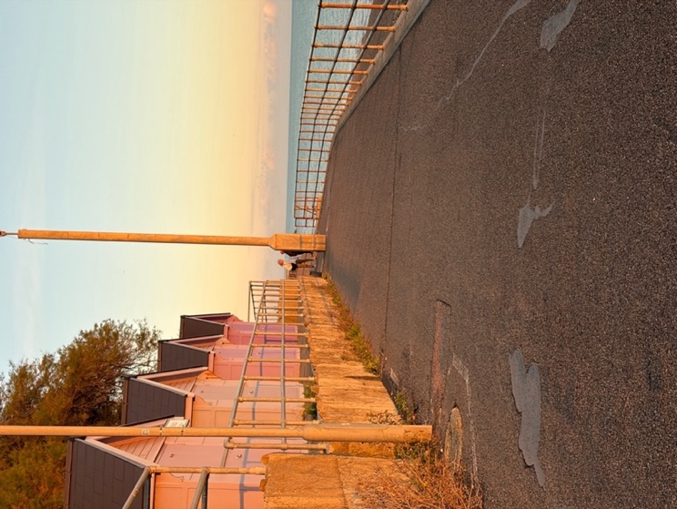
Please be aware that some parts of the route may be covered with shingle from the beach which may make access more challenging for users with low mobility and wheelchair users:

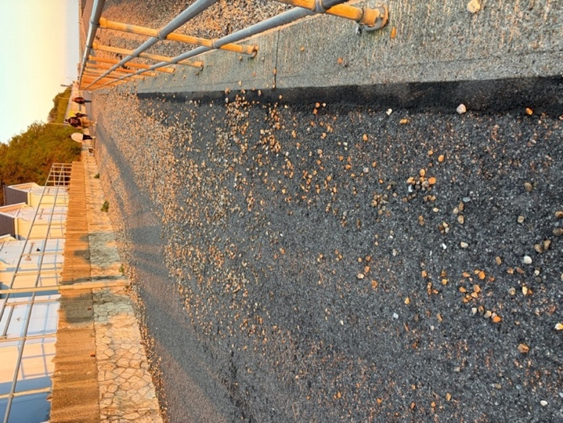

- Continue to follow the KCIIIECP and look out for the Leas Lift which connects the Lower and Upper Leas 6 . It is currently out of commission. Looking up onto the Leas, you will see the Step Short Arch, commemorating the many soldiers who were shipped into and out of Folkestone. Also here is the splendid architecture of the Leas Cliff Hall jutting out of the escarpment.
Accessibility
The Leas promenade is wide and level, ideal for wheelchairs and scooters, with plenty of seating and accessible viewpoints. The Leas Lift is currently out of commission, so step-free access between Upper and Lower Leas is limited to alternative routes. The lift is currently being restored: Leas Lift Home.

- The path heads towards the old Folkestone Harbour railway station platform across a boardwalk in the shingle. In 2016, work commenced to restore the Harbour Railway and in 2017 the harbour was opened as a pedestrian route to the station. Several artworks from the Folkestone Triennial are installed in the station.

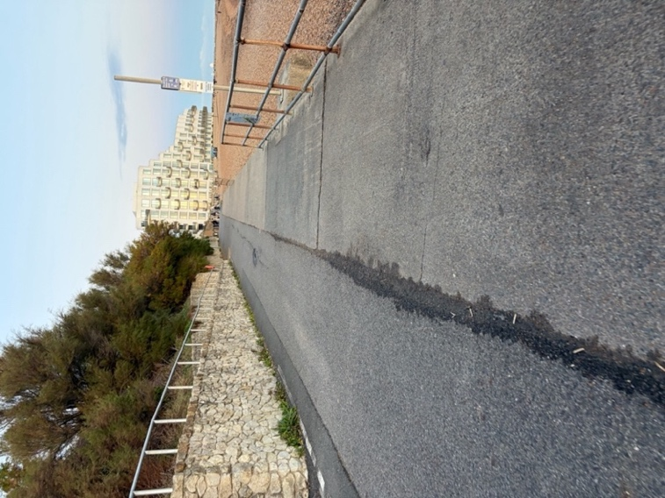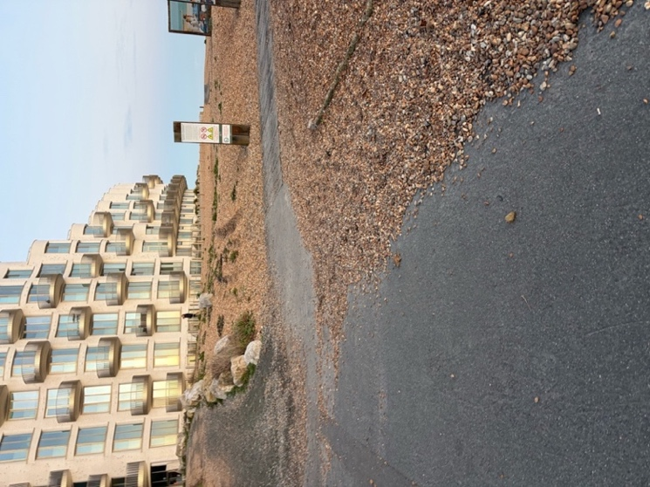

Accessibility
The boardwalk across the shingle to Folkestone Harbour is accessible with a firm wooden surface and gentle gradients however care should be taken as it may be covered with shingle in places:

In addition, there are no railings or clear edging to either side. Art installations are positioned along the route and can be appreciated without leaving the accessible path. The Harbour Arm and surrounding cultural areas are largely level and accessible, with smooth surfaces and step-free access to most facilities including accessible toilets.

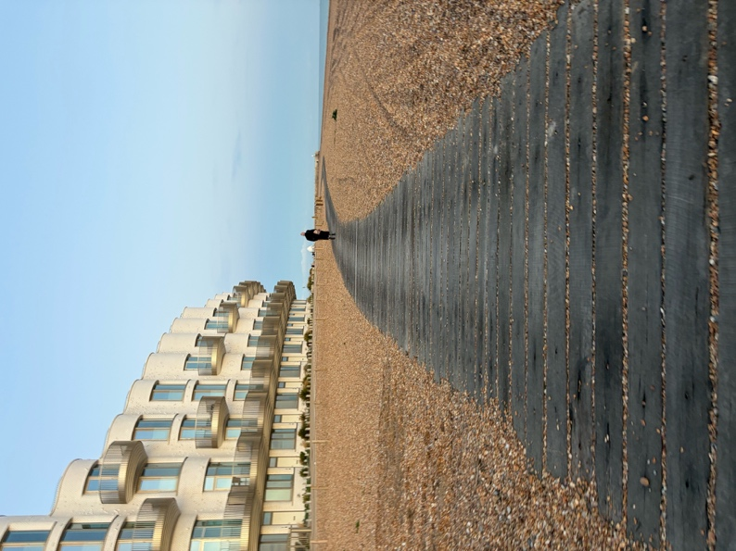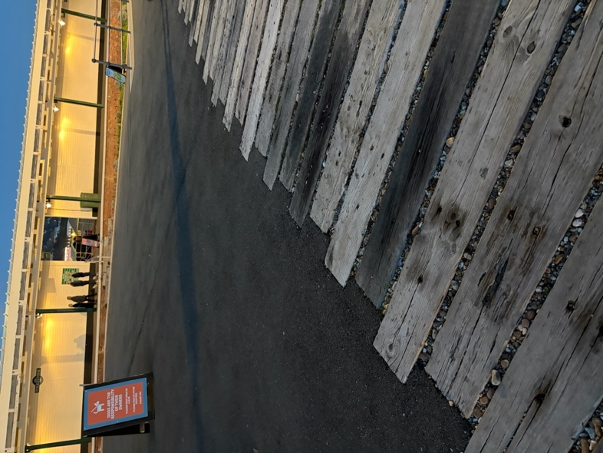

- No visit to Folkestone is complete without visiting the Old High Street and Creative Quarter. Don’t miss the Folkestone Artworks set around the harbour and its sea wall arm. Be sure to spend some time in this cultural town and sample some food and drink from around the harbour and Harbour Arm where your walk ends. The Leas is Folkestone’s unique cliff top promenade. Folkestone’s newly restored Harbour Arm where your walk ends.
Accessibility
The Old High Street has some steep gradients and uneven paving, which may pose challenges for wheelchair users.

